* **Create Maven Project 🡪 Install library**

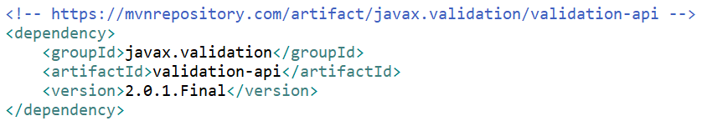

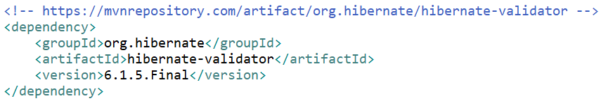

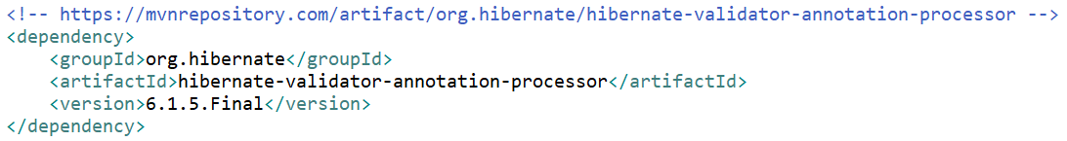

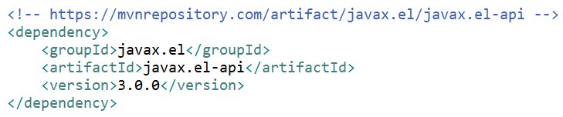

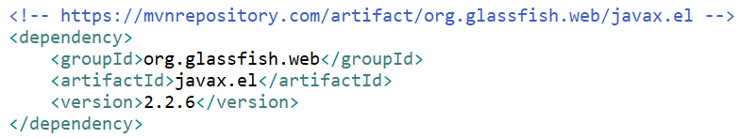

[*https://mvnrepository.com/artifact/javax.validation/validation-api/2.0.1.Final*](https://mvnrepository.com/artifact/javax.validation/validation-api/2.0.1.Final)

[*https://mvnrepository.com/artifact/org.hibernate/hibernate-validator/6.1.5.Final*](https://mvnrepository.com/artifact/org.hibernate/hibernate-validator/6.1.5.Final)

[*https://mvnrepository.com/artifact/org.hibernate/hibernate-validator-annotation-processor/6.1.5.Final*](https://mvnrepository.com/artifact/org.hibernate/hibernate-validator-annotation-processor/6.1.5.Final)

[*https://mvnrepository.com/artifact/javax.el/javax.el-api/3.0.0*](https://mvnrepository.com/artifact/javax.el/javax.el-api/3.0.0)

[*https://mvnrepository.com/artifact/org.glassfish.web/javax.el/2.2.6*](https://mvnrepository.com/artifact/org.glassfish.web/javax.el/2.2.6)

* **Create Object**

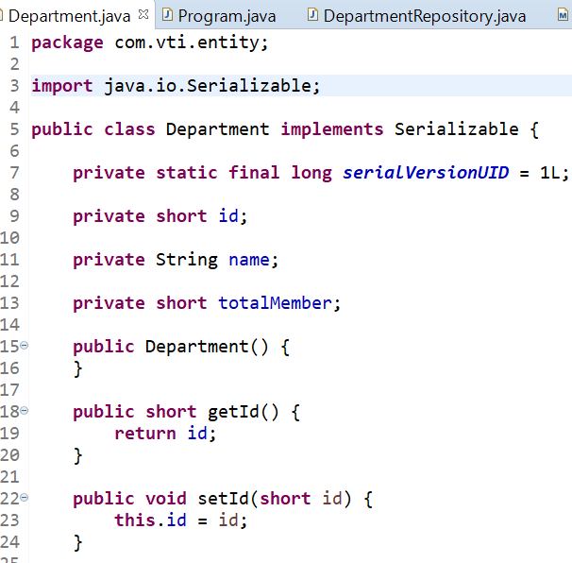

* **Add validation Configuration**

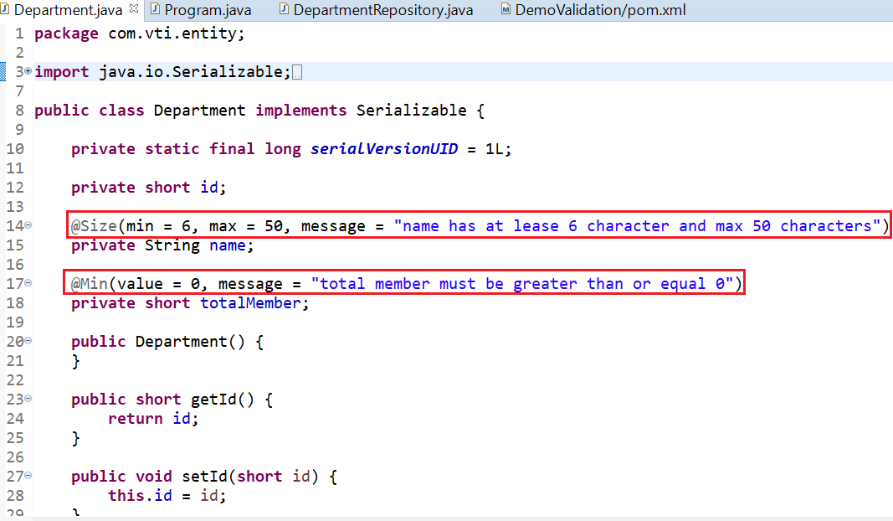

* **Validate**

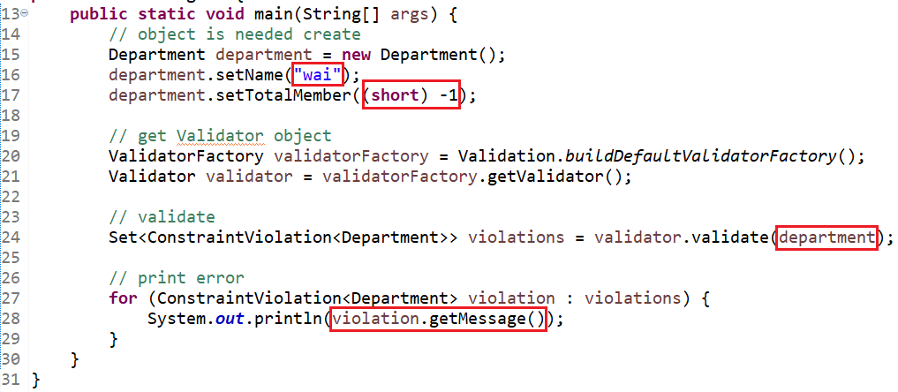

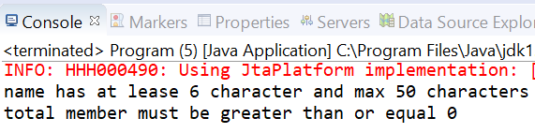

*Violation*

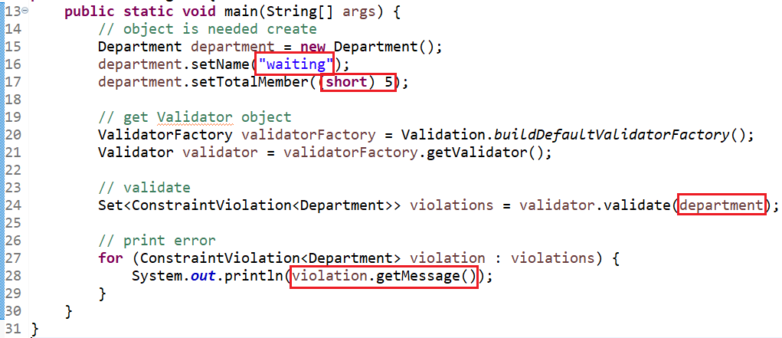

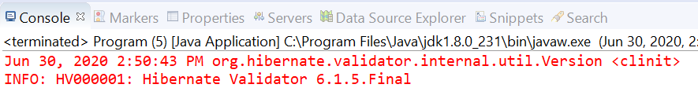

*Non violation*

* **Reference**